WOMEN GOING FOR IT! TAKING RISKS AFTER 50
By Diana Coleman

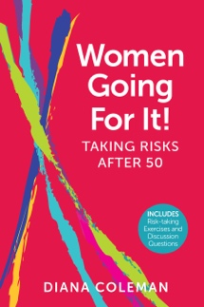

Twenty-six dynamic women, 50s through 80s, share their captivating, risk-taking stories with grit and humor in the book Women Going For It! Taking Risks After 50. Donating a kidney to a stranger, building schools in Ethiopia, racing around a Roller Derby track … these women pursue adventures, interests and life changes. Feisty, tough and determined, despite fears and challenges, they triumph over obstacles and persevere. Risk-taking tips and stimulating discussion questions are also featured. From Maine to California, Costa Rica to Kenya, these women’s enlightening stories celebrate resilience and will inspire you to take meaningful risks.

ABOUT THE AUTHOR-DIANA COLEMAN

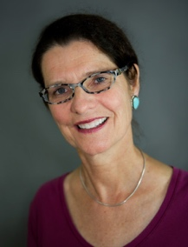

Believing in female fortitude and risk-taking power, Diana Coleman shares compelling stories of women enjoying new experiences, riveting adventures, and life-changing risks in her book Women Going For It! Taking Risks After 50. She has lectured around the country about women and girls overcoming daunting challenges. A former administrator and fundraiser for organizations including Save the Children, the University of California, Berkeley, Pen Bay Healthcare, and the International Museum of Women, Diana’s work and studies have taken her to Central America, Africa and Asia. Her travel essays are published in the Goose River Anthology. She serves on the board of Mpanzi, supporting women and girls in Kenya. Diana has a BA from Russell Sage College and an MA from American University, Washington, DC. Originally from Massachusetts, Diana lived thirty years in San Francisco and, when not traveling, resides in Maine. Her website is WomenGoingForIt.com.

